**Session 5**

**-**

**Display devices, 7-segment display**

**Author:** Guillermo Cortés Orellana

**Teacher:** Tomáš Frýza



Lab assignment

1. **Preparation tasks**

* Table with segments values for display 0 to 9 on a common anode 7-segment display

|  |  |  |  |  |  |  |  |  |
| --- | --- | --- | --- | --- | --- | --- | --- | --- |
| Digit | A | B | C | D | E | F | G | DP |
| 0 | 0 | 0 | 0 | 0 | 0 | 0 | 1 | 1 |
| 1 | 1 | 0 | 0 | 1 | 1 | 1 | 1 | 1 |
| 2 | 0 | 0 | 1 | 0 | 0 | 1 | 0 | 1 |
| 3 | 0 | 0 | 0 | 0 | 1 | 1 | 0 | 1 |
| 4 | 1 | 0 | 0 | 1 | 1 | 0 | 0 | 1 |
| 5 | 0 | 1 | 0 | 0 | 1 | 0 | 0 | 1 |
| 6 | 0 | 1 | 0 | 0 | 0 | 0 | 0 | 1 |
| 7 | 0 | 0 | 0 | 1 | 1 | 1 | 1 | 1 |
| 8 | 0 | 0 | 0 | 0 | 0 | 0 | 0 | 1 |
| 9 | 0 | 0 | 0 | 0 | 1 | 0 | 0 | 1 |

* In your words, describe the difference between Common Cathode and Common Anode 7-segment display

**Common Cathode** **7-segment display**, has the cathodes of 7 segments connected to each other, instead of **Common Annode 7-segment display,** which has the anodes of 7 segments connected to each other.

In addition, **Common Cathode** turn on the LED with ‘1’ and turn off with ‘0’, as opposed to **Common Annode,** which turn on the LED with ‘0’ and turn off with ‘1’.

1. **7-segment library**

* Listing of library source file ***segment.c***

**Note:** SEG_clk_2us() function is designed so that it will generate 1 period of a clock signal with a **frequency of 800kHz** such as it is explained in the section ‘Experiments on your own’

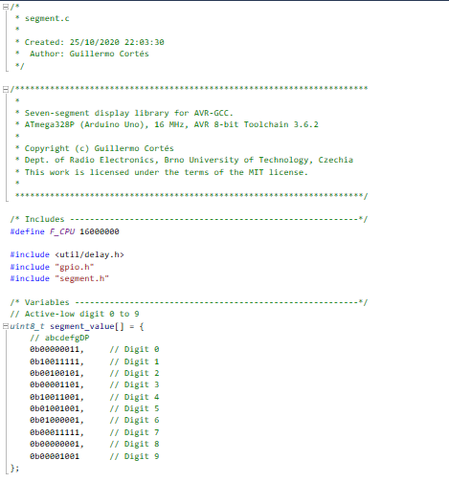

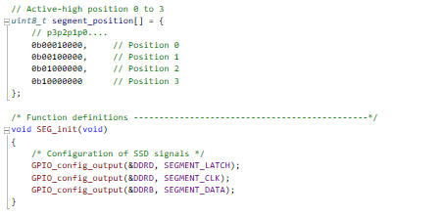

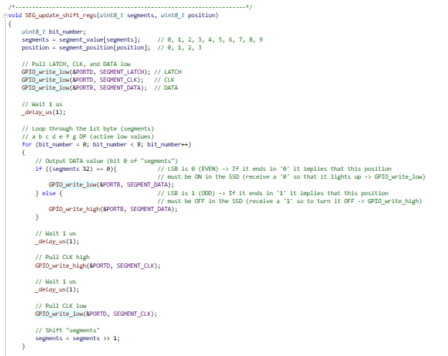

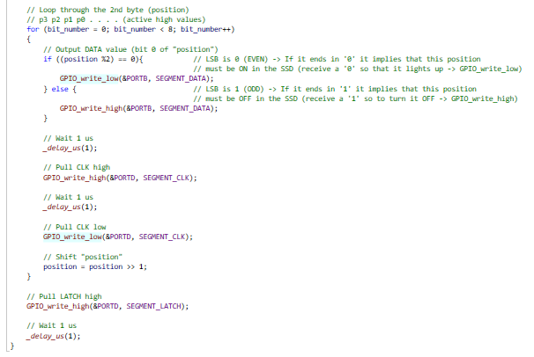

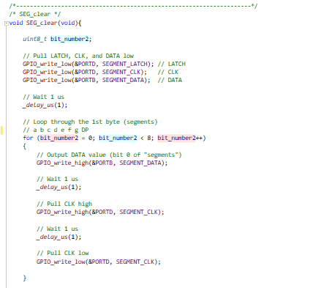

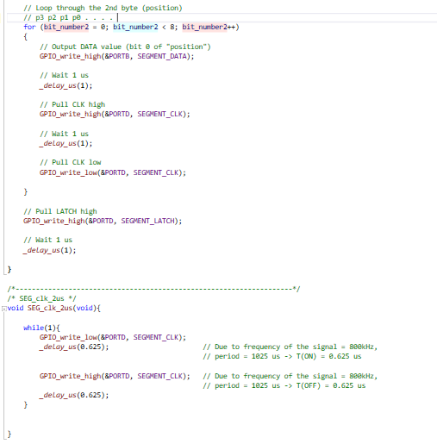

You can find the code on my GitHub:

https://github.com/GuicoRM/Digital-Electronics-2

* Listing of decimal counter application ***main.c***  (two digits, from 00 to 59)

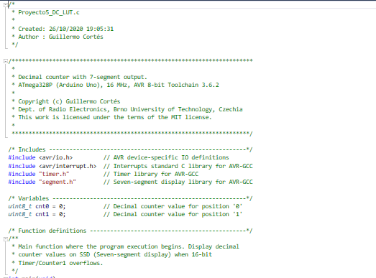

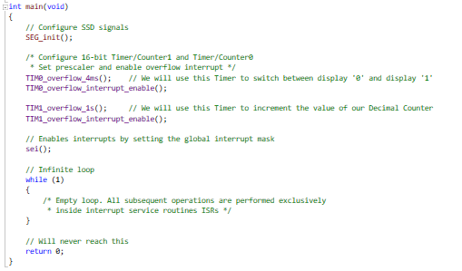

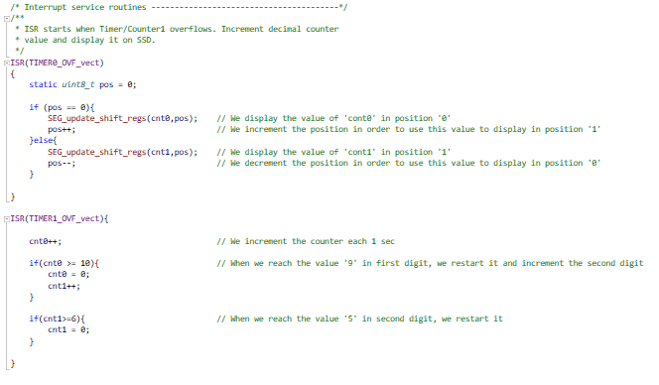

You can find the code on my GitHub:

https://github.com/GuicoRM/Digital-Electronics-2

* Screenshot of SimulIDE circuit

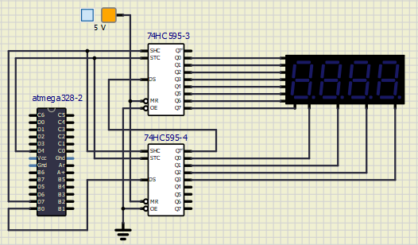

1. **Snake**

* Look-up table with snake definiton

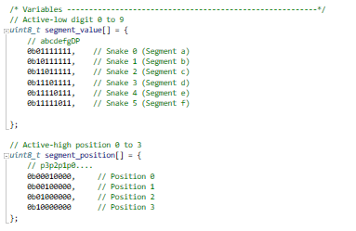

You can find the code on my GitHub:

https://github.com/GuicoRM/Digital-Electronics-2

* Listing of snake cycling application ***main.c*** (four digits snake)

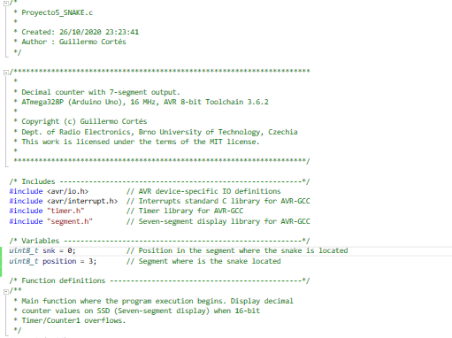

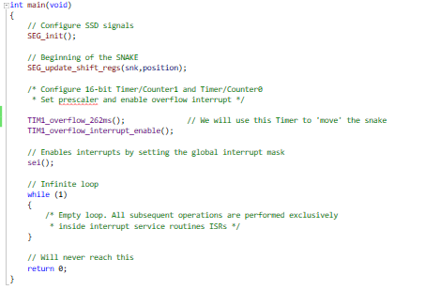

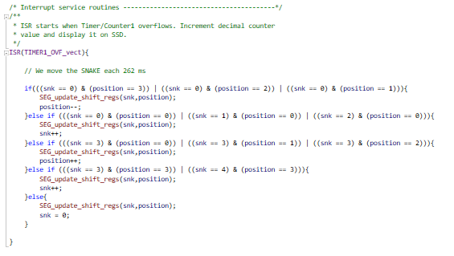

You can find the code on my GitHub:

https://github.com/GuicoRM/Digital-Electronics-2